**General Test Method for Working Pressure and Proof Pressure Testing**

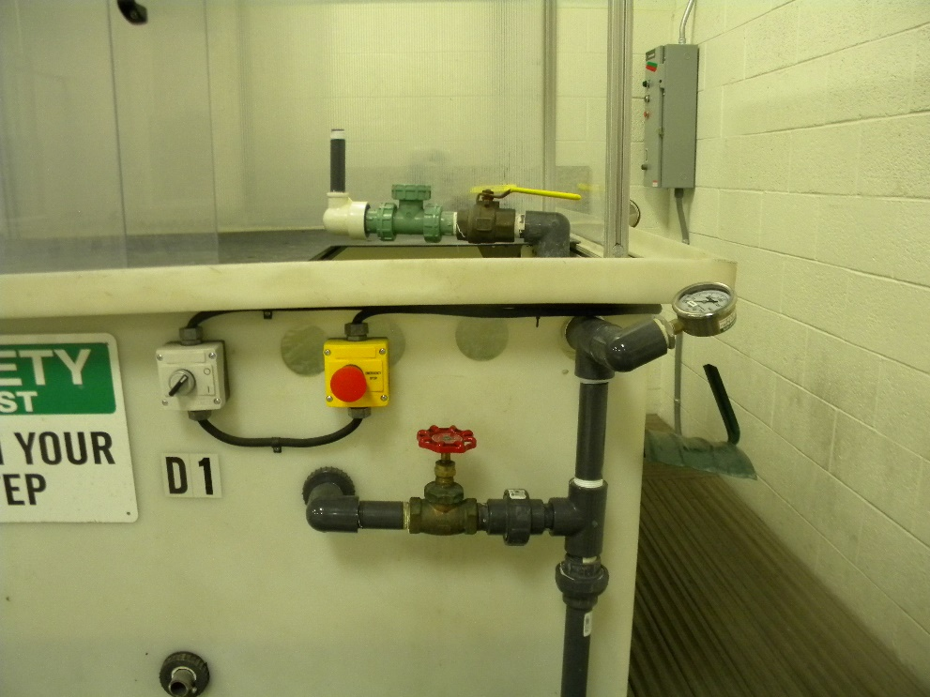

CONTENTS

1 Equipment 3

1.1 Spring Load Pop-Up (SLPU) Specific Equipment 3

1.2 Gear Drive Specific Equipment 3

1.3 Inline Valve Specific Equipment 3

1.4 Impact Sprinkler Specific Equipment 3

1.5 Anti-Syphon Valve Specific Equipment 3

1.6 Blu-Lock Pipe and Fitting Specific Equipment 4

2 Software 4

3 Setup 4

3.1 SLPU Water Test Setup: 4

3.2 Gear Drive Sprinkler Water Test Setup: 4

3.3 Inline Valve Water Test Setup: 5

3.4 Impact Sprinkler Water Test Setup: 5

3.5 Anti-Syphon Valve Water Test Setup: 6

3.6 Blu-Lock Pipe and Fitting Water Test Setup: 6

4 General Test Procedure 7

4.1 Spring Load Pop-Up (SLPU) Water Testing 7

4.2 Gear Drive Sprinkler Water Testing 9

4.3 Inline Valve Water Testing 10

4.4 Impact Sprinkler Water Testing 12

4.5 Anti-Syphon Valve Water Testing 14

4.6 Blu-Lock Pipe and Fittings Water Testing 19

5 Data Format and Reporting 21

5.1 Section 4.1 21

5.2 Section 4.2 21

5.3 Section 4.3 21

5.4 Section 4.4 21

5.5 Section 4.5 21

5.6 Section 4.6 21

1. Equipment

The Following Equipment is required for this testing:

* 1. Spring Load Pop-Up (SLPU) Specific Equipment
     1. Calibrated Pressure Gauge
        1. The pressure gauge must be calibrated and have a minimum pressure capability of 100 psi.
     2. Water Test Tank
        1. Test tank must be capable of changing pressure, which includes valves, pumps, and piping. The pump should be capable of supplying water at a minimum flow rate of 6.0 GPM at 70 psi.
  2. Gear Drive Specific Equipment
     1. Calibrated Pressure Gauge
        1. The pressure gauge must be calibrated and have a minimum pressure capability of 140 psi.
     2. Water Test Tank
        1. Test tank must be capable of changing pressure, which includes valves, pumps, and piping. The pump should be capable of supplying water at a minimum flow rate of 10 GPM at 65 psi.
  3. Inline Valve Specific Equipment
     1. Calibrated Pressure Gauge
        1. The pressure gauge must be calibrated and have a minimum pressure capability of 175 psi.
     2. Water Test Tank
        1. Test tank must be capable of changing pressure, which includes valves, pumps, and piping. The pump should be capable of supplying water at a minimum flow rate of 45 GPM at 150 psi.
  4. Impact Sprinkler Specific Equipment
     1. Calibrated Pressure Gauge
        1. The pressure gauge must be calibrated and have a minimum pressure capability of 150 psi.
     2. Water Test Tank
        1. Test tank must be capable of changing pressure, which includes valves, pumps, and piping. The pump should be capable of supplying water at a minimum flow rate of 6.0 GPM at 100 psi.
  5. Anti-Syphon Valve Specific Equipment
     1. Calibrated Pressure Gauge
        1. The pressure gauge must be calibrated and have a minimum pressure capability of 175 psi.
     2. Water Test Tank
        1. Test tank must be capable of changing pressure, which includes valves, pumps, and piping. The pump should be capable of supplying water at a minimum flow rate of 45 GPM at 150 psi.
     3. Back Pressure Control Fixture
        1. The back pressure control fixture is a device used to add back pressure to the outlet of the anti-syphon valve. The fixture consists of a set of adapters, a calibrated pressure gauge, and a globe valve.
  6. Blu-Lock Pipe and Fitting Specific Equipment
     1. Hydrostatic Pump Tank or Water Test Tank
        1. Water supplied to the must be able to achieve 10 to 200 psi of water pressure. Equipment shall include all valves, pumps, piping, and fittings to achieve a functional tank.
     2. Calibrated Pressure Gauge
        1. The pressure gauge must be calibrated and have a minimum pressure capability of 200 psi.

1. Software

None Required

1. Setup
   1. SLPU Water Test Setup:



* + 1. Parts Needed: water pump, tank, pressure control valve, pressure gauge, properly sized riser, piping, and adapters.
  1. Gear Drive Sprinkler Water Test Setup:



* + 1. Parts Needed: water pump, tank, pressure control valve, pressure gauge, properly sized riser, piping, and adapter.
  1. Inline Valve Water Test Setup:

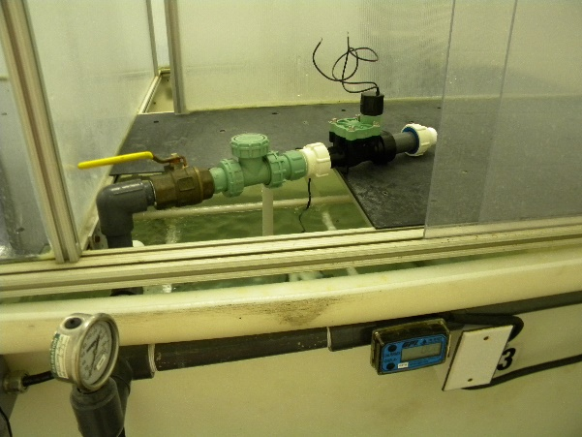

* + 1. Parts Needed: water pump, tank, pressure control valve, pressure gauge, properly sized adapters, piping, and related attachment fittings.
  1. Impact Sprinkler Water Test Setup:



* + 1. Parts Needed: water pump, tank, pressure control valve, pressure gauge, piping, and related attachment fittings.
  1. Anti-Syphon Valve Water Test Setup:

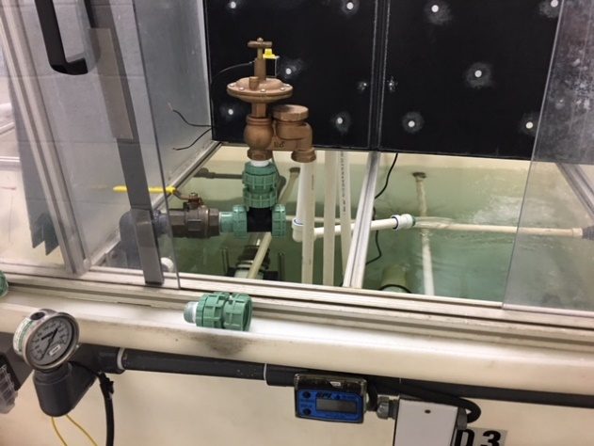 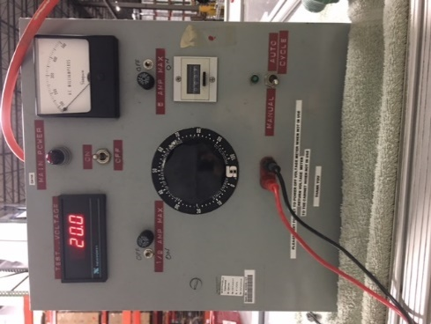 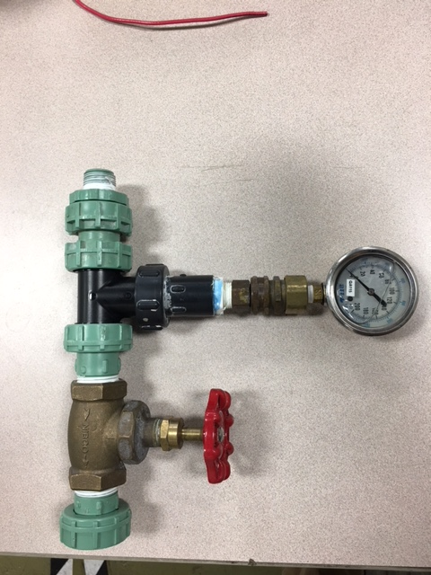

* + 1. Parts Needed: Plumbing, adapters, pump, pressure gauge, water tank, voltage regulator, back pressure valve setup.
  1. Blu-Lock Pipe and Fitting Water Test Setup:

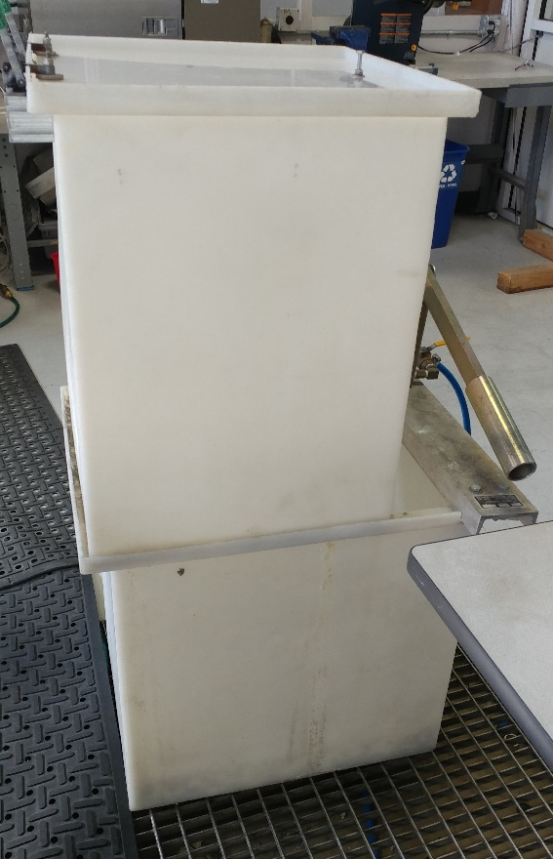

* + 1. Parts Needed: Hydrostatic or Water Test Tank with associated plumbing and pressure gauge.

1. General Test Procedure
   1. Spring Load Pop-Up (SLPU) Water Testing
      1. Attach SLPU to riser *(Fig 1)*.

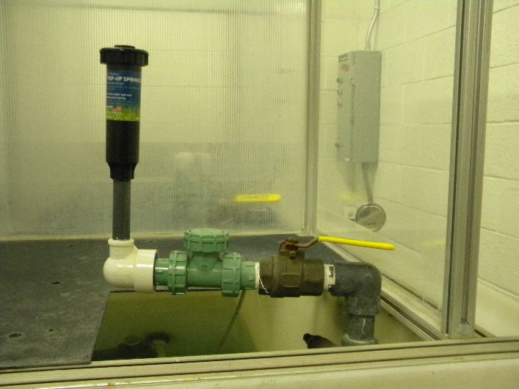

*Figure 1: SLPU attached to riser.*

* + 1. Fully open pressure control valve and turn water on.
    2. Increase the dynamic water pressure to 10 psi.
    3. Check for excessive leakage between the stem/wiper seal and cap/can interfaces *(Fig 3)*. Excessive leakage is defined as >10 drips per minute or an airborne stream.
    4. Continue to increase pressure until full extension [FE] of stem is achieved. Make note of FE pressure *(Fig 2)*.

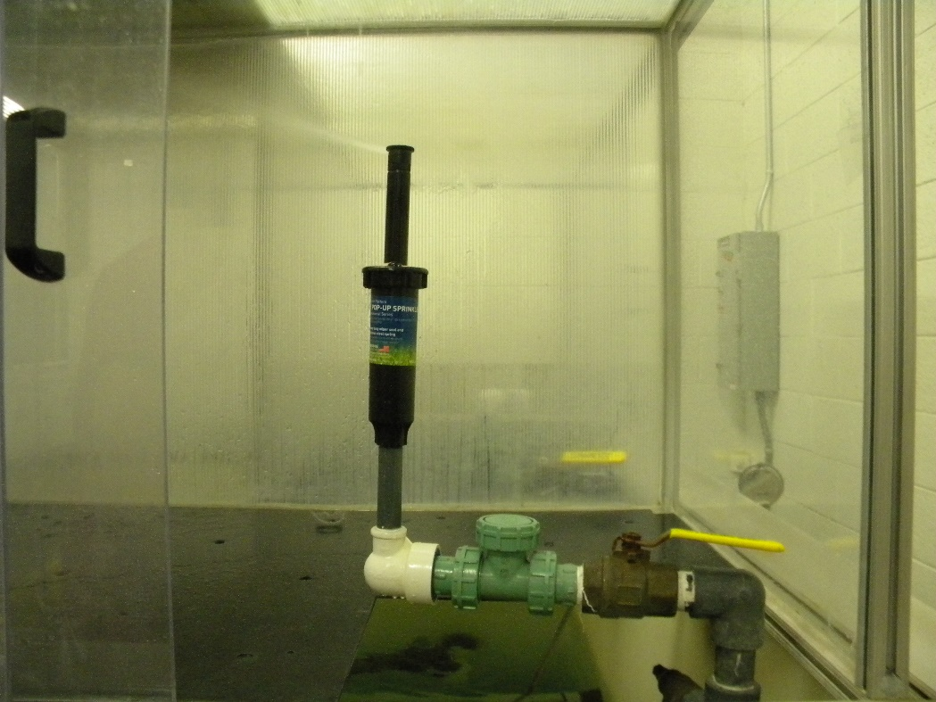

*Figure 2: SLPU at full extension.*

* + 1. If pressure at FE is greater than the minimum working pressure, decrease the pressure to the minimum dynamic working pressure.
    2. Check for leaking between the stem/wiper seal, cap/can, body/threads, and nozzle/stem *(Fig 3)*. Airborne leakage will be considered unacceptable. See the General Specification for a definition of “leakage”.

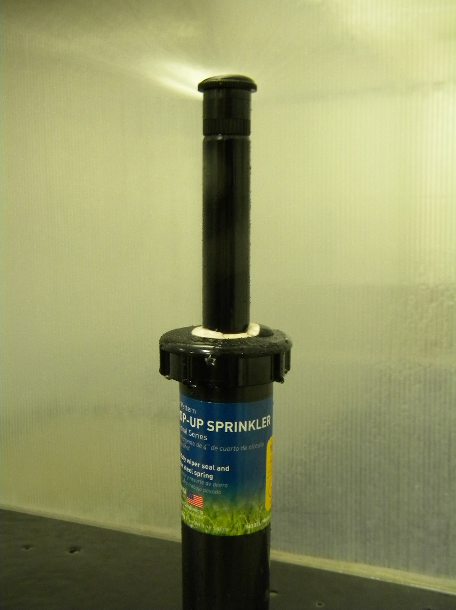

*Figure 3: Check for leaking at the arrows.*

* + 1. Increase the pressure to the maximum dynamic working pressure.
    2. Repeat step 4.1.7 for the maximum dynamic working pressure.
    3. Turn pump off and ensure the SLPU fully retracts.
  1. Gear Drive Sprinkler Water Testing
     1. Attach Gear Drive to riser *(Fig 4)*.

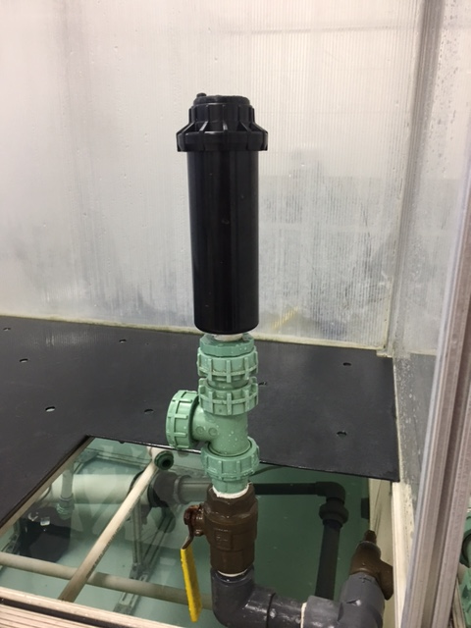

*Figure 4: Gear Drive attached to riser.*

* + 1. Fully open pressure control valve and turn water pump on.
    2. Increase pressure until full extension [FE] of stem is achieved. Take note of FE pressure *(Fig 5)*.

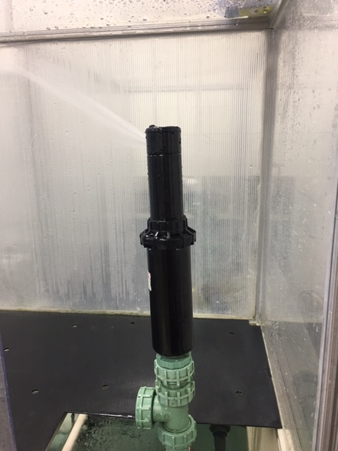

*Figure 5: Gear Drive at full extension [FE].*

* + 1. Reduce or increase pressure to desired pressure (dynamic), whether this is min/max working pressure or proof pressure. These values are specified in the Gear Drive’s specific General Specification.
    2. Check for leaking between the stem/wiper seal, cap/can, body/threads, and nozzle/stem *(Fig 6)*. See the general specification for a definition of “leakage”.

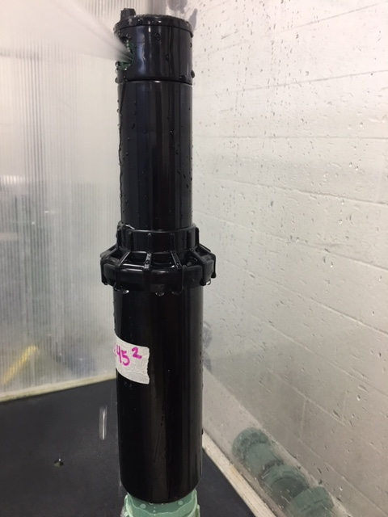

*Figure 6: Check for leaking at the arrows.*

* + 1. At the desired pressure, time the Gear Drive for one full rotation cycle (head switching direction clockwise and counter-clockwise). Make sure the head switches directions.
    2. Once all desired pressures have been checked, turn the pump off and ensure that the Gear Drive fully retracts.
  1. Inline Valve Water Testing
     1. Mount the valve to the water test tank using proper adapters depending on which valve you are testing *(Fig 7)*.

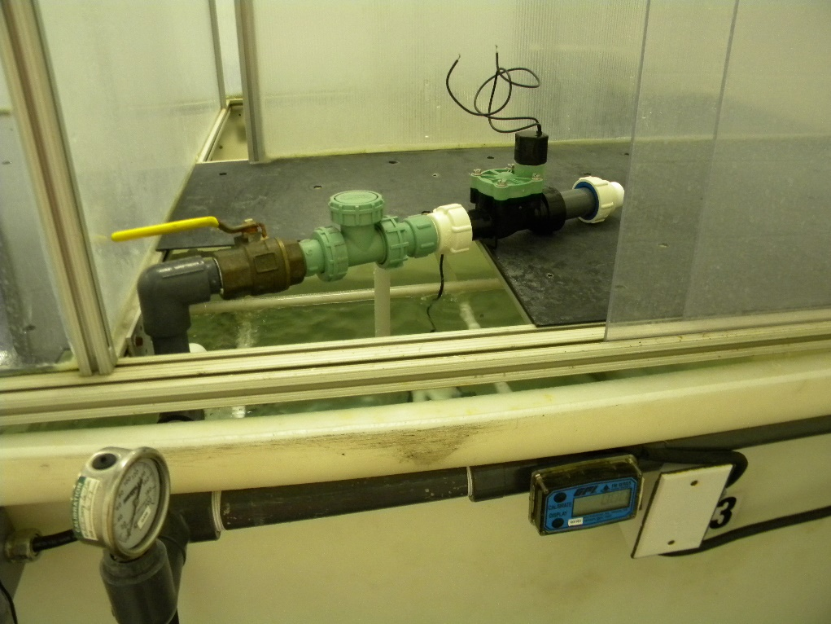

*Figure 7: Valve mounted to test tank.*

* + 1. Flow water through the valve with the solenoid energized or in the open position, allowing air to be evacuated from the valve *(Fig 8)*.

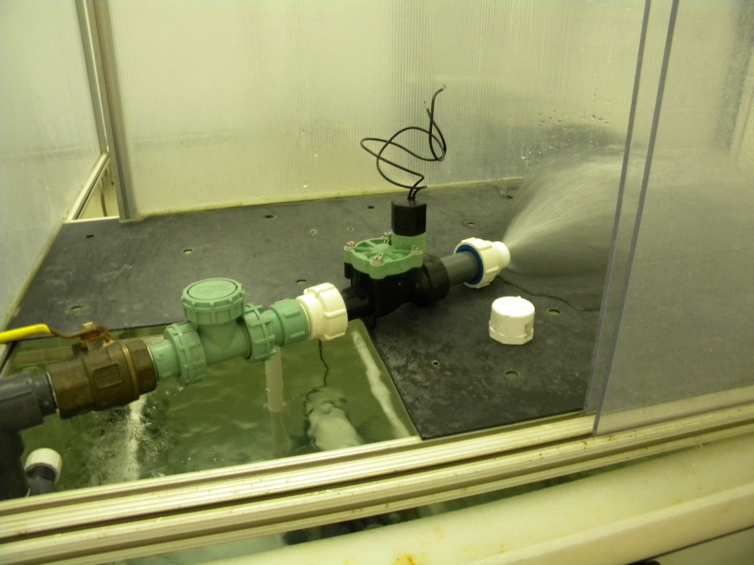

*Figure 8: Evacuating air from valve.*

* + 1. Reduce the water flow to a trickle and keep the solenoid in the open position. Cap the end of the valve, creating a pressure vessel and keep the air out of the valve *(Fig 9)*.

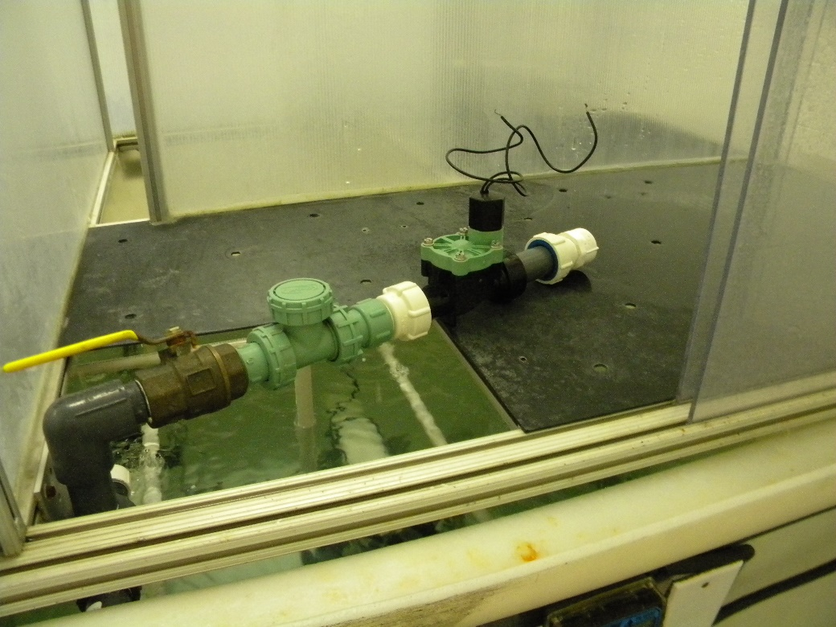

*Figure 9: Valve capped*

* + 1. Blow off all residual water sitting on the sealing surfaces of the valve, including threads/push-fittings, lid/body interface, and solenoid/lid interface.
    2. While keeping the solenoid open, pressurize the valve to the minimum working pressure and inspect all areas listed in step 4.3.4 for leaking. Continue this for a minimum of one minute *(Fig 10)*.

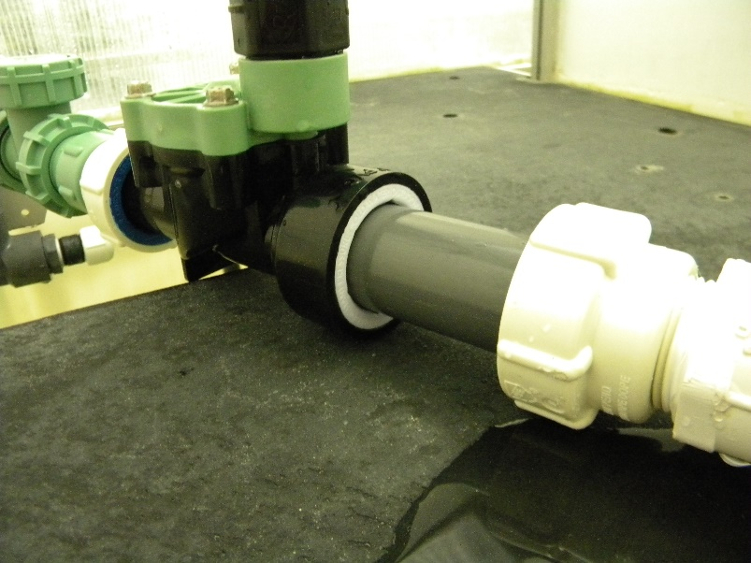

*Figure 10: Inspect the areas with arrows.*

* + 1. Note any leaking and include a drip rate. If dripping is above three drips per minute, the test will be considered a failure.
    2. Increase the pressure to the maximum working pressure and hold for one minute, repeating step 4.3.6.
    3. Reduce the pressure and turn the pump off.
  1. Impact Sprinkler Water Testing
     1. Attach Impact sprinkler to test tank using attachment fittings *(Fig 11)*.

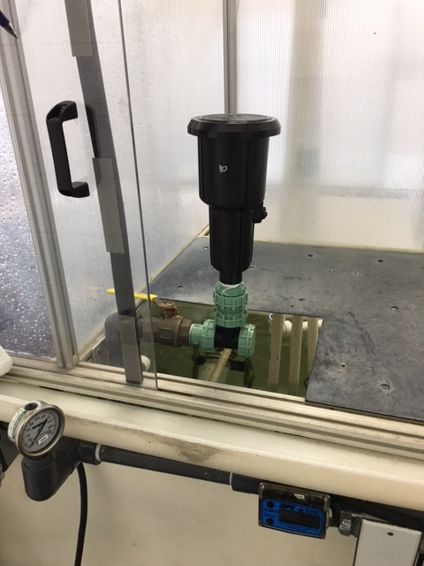

*Figure 11: Impact attached to tank.*

* + 1. Fully open pressure control valve and turn water pump on.
    2. (Optional) If you are testing a pop-up impact, increase pressure until full extension [FE] of stem is achieved. Take note of FE pressure *(Fig 12)*.

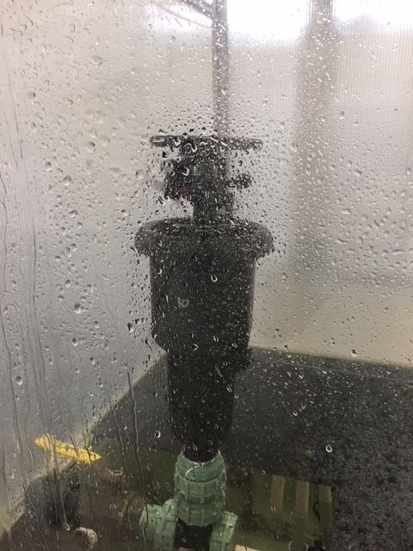

*Figure 12: Pop-Up Impact at full extension [FE].*

* + 1. Increase pressure to desired dynamic pressure, whether this is min/max working pressure or proof pressure. These values are specified in the Impact’s General Specification.
    2. Check for leaking between the stem/wiper seal (pop-up only), threads/adapter, nozzle/head, and journal bearing *(Fig 13)*.

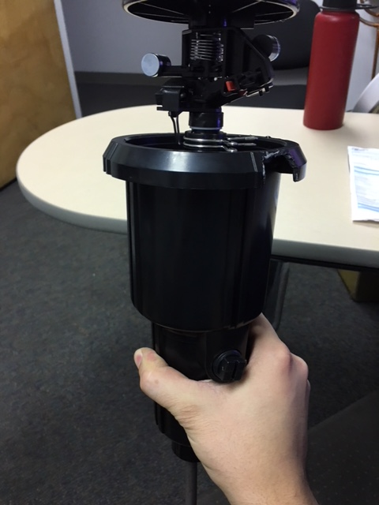

*Figure 13: Check for leaking at the arrows.*

* + 1. Ensure that the head is able to switch both directions when the lever arm is tripped throughout all required pressure ranges.
    2. Once all desired pressures have been checked, turn the pump off and for Pop-Up Impacts, ensure that the unit fully retracts.
  1. Anti-Syphon Valve Water Testing

*Note: This procedure covers general working pressure testing, general solenoid function testing, and air vent cap leak testing.*

* + 1. Attach the valve to the test tank using proper attachments *(Fig 14)*.

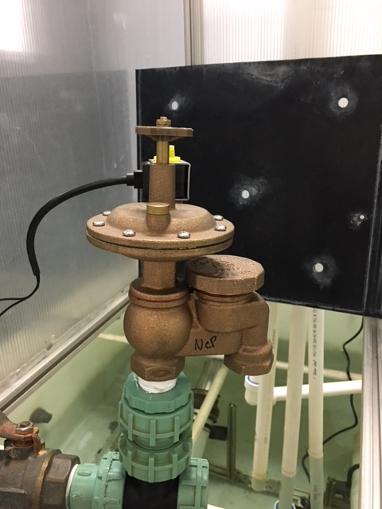

*Figure 14: Valve attached to test tank.*

* + 1. Attach the back pressure control fixture to the outlet of the valve *(Fig 15)*.

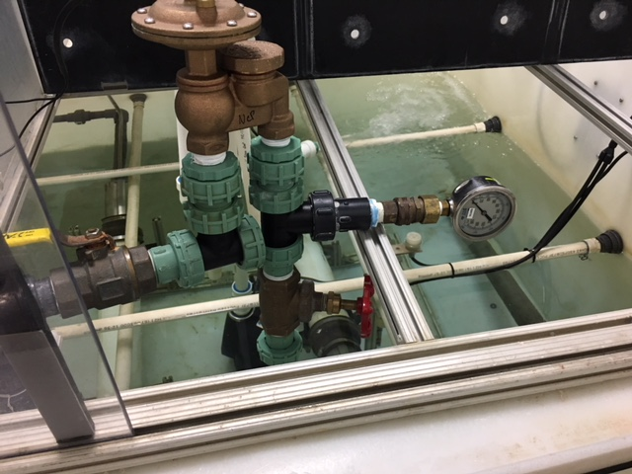

*Figure 15: Back pressure control fixture attached to the valve.*

* + 1. Fully open the globe valve so essentially 0 psi of back pressure is exerted on the valve.
    2. Set the voltage regulator to the desired voltage, outlined in the General Specification *(Fig 16)*. Typically, the lowest voltage requirement is tested first, and then the upper voltage requirement is tested.

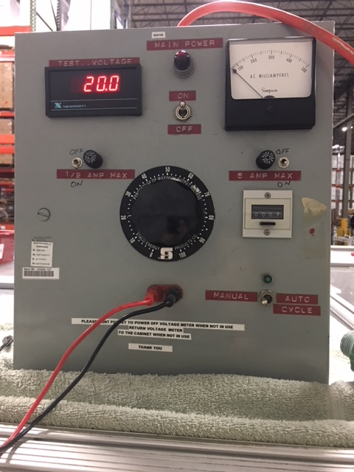

*Figure 16: Setting voltage regulator*

* + 1. Turn the water pump on to the valve and set the static pressure to the minimum working pressure outlined in the General Specification.
    2. Check for leaking at the arrows in *Figure 17* below.

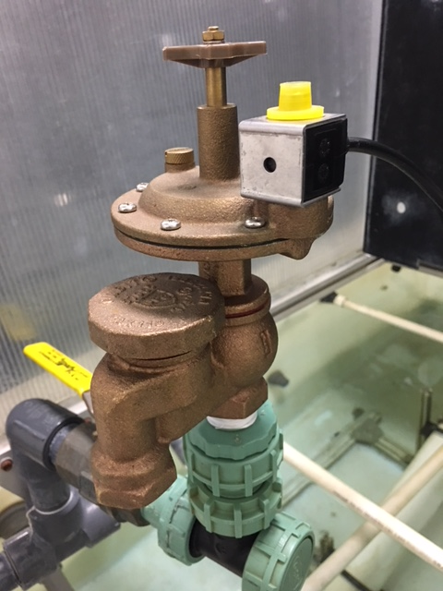

*Figure 17: Check for leakage at the arrows.*

* + 1. Attach the wire leads from the voltage regulator to the solenoid so that the valve turns on.
    2. As water begins to flow through the valve, check for leaking at the arrows in *Figure 18* below.



*Figure 18: Check for leakage at the arrows.*

* + 1. If water is leaking from the air vent cap, begin to close the globe valve downstream, adding back pressure to the valve *(Fig 19)*. Do this slowly.



*Figure 19: Adjust globe valve (red arrow). Read pressure gauge (green arrow).*

* + 1. Continue to add back pressure until the leaking from the air vent cap stops. At that point, record the back pressure needed to stop the leaking, which will be indicated on the back pressure control fixture’s gauge *(Fig 19 above)*.
    2. Remove the wire leads from the solenoid, so that the valve closes.
    3. Increase the static pressure to the maximum working pressure, outlined in the General Specification.
    4. Repeat steps 4.6.6-4.6.8.
    5. Remove the wire leads from the solenoid, so that the valve closes.
    6. Lower the static water pressure back down to the minimum working pressure.
    7. Adjust the voltage regulator so that it is set to the upper voltage limit.
    8. Attach the wire leads to the solenoid, ensuring that the valve opens properly.
    9. Remove the leads from the solenoid. The valve should close. If the valve does not close after several seconds, the valve will be considered a failure.
    10. Increase the static water pressure to the upper working pressure limit.
    11. Attach the wire leads to the solenoid, ensuring that the valve opens as it should.
    12. Remove the leads from the solenoid. The valve should close.
    13. Lower the water pressure back down to the lower working pressure limit.
    14. Turn the water pump off and remove the valve from the tank.
  1. Blu-Lock Pipe and Fittings Water Testing
     1. Create a pressure vessel using the appropriate pipe (minimum of ~6” in length) and fitting combination *(Fig 20)*.

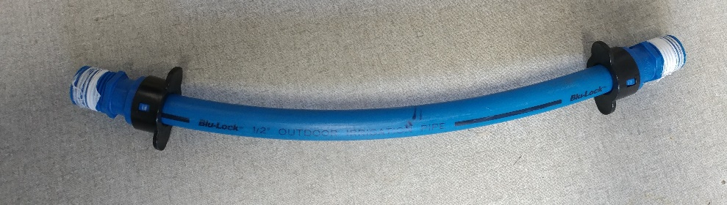

*Figure 20: Pipe and fitting combination*

* + 1. Attach one end of the pressure vessel to the inlet of the tank and leave the other end of the vessel open to atmosphere *(Fig 21)*.

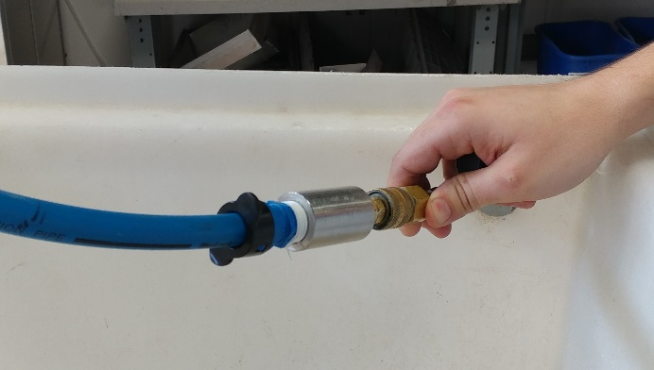

*Figure 21: Vessel attached to tank*

* + 1. Turn the water on to the tank and evacuate the air from the vessel *(Fig 22)*.

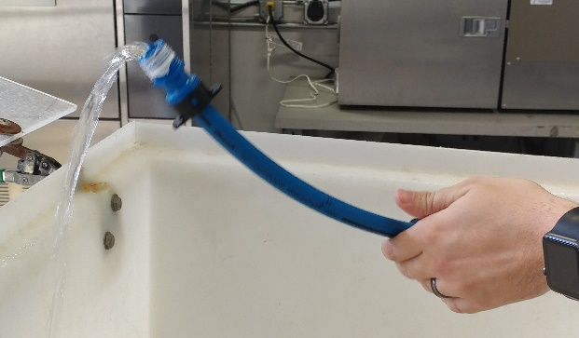

*Figure 22: Evacuate water*

* + 1. Cap the outlet of the pressure vessel once the air has been removed *(Fig 23)*.

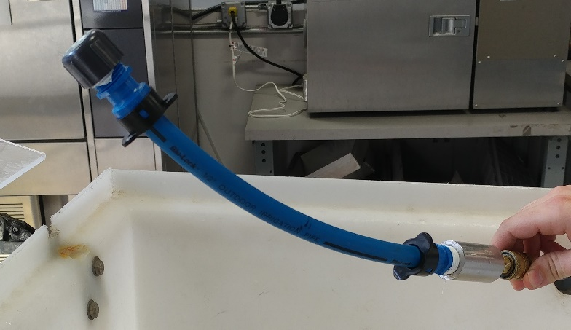

*Figure 23: Pressure vessel capped*

* + 1. Apply the specified pressure found in the General Specification to the vessel, allowing the pressure vessel to vary throughout the specified pressure range. This may be the working or proof pressure, depending on the test being performed.
    2. Ensure that the time requirement found in the General Specification is met before completing the test.
    3. Remove pressure from the system and disassemble the pressure vessel.
    4. Record any failure or leaking. Leaking above 3 drips per minute shall constitute a failure.

1. Data Format and Reporting
   1. Section 4.1
      1. Pressure at full extension
      2. Any leakage
      3. Any other noted failure
   2. Section 4.2
      1. Pressure at full extension
      2. Any leakage
      3. Any other noted failure
   3. Section 4.3
      1. Leaking
   4. Section 4.4
      1. Pressure at full extension
      2. Lowest pressure impact is fully functioning
      3. Highest pressure impact is fully functioning
      4. Any issues during testing
   5. Section 4.5
      1. Any leakage
      2. Pressure at which air vent cap stops leaking
   6. Section 4.6
      1. Any leakage/leakage rate

* END *